Different kind of Organs

❖ DIFFERENT KIND OF ORGANS:
1. Organs of smell: In some insects the smell organs (sensoria) are situated in the antennae by
which they recognize their food etc. e.g., Ants, honeybee.
2. Organs of taste: Some insects bear taste hair on their antennae by which they know the taste
of their food e.g., cockroach.
3. Stridulatorial organs: Sound producing organs are in the antennae of some insects
belonging to the orders-coleopteran and orthopteran e.g., cricket.
4. Organs of chordotonal: The hearing organs often known as Johnston’s organs are situated
in the second segment (pedicel) of antenna e.g., male mosquito.
5. Sexual characters: In some of the insects belonging to the order Diptera and Hemiptera, the
antennae are found of different type in male and female viz. mosquito.
6. Other functions: In some larvae the antennae are adapted for seizing the prey e.g.,
Chaborus, while in other insects they are used for holding the females. e.g., the male of meloe.
The butterflies are having some transmitting and receiving organs in their antennae.
❖ Mouth parts:
➢ Important for insect identification.
➢ Provides information on feeding habits and types of damage
Mouth Part
Remarks
Labrum or upper lip
It is with a ventral surface called
the epipharynx
Hypopharynx
A tongue like structure
Mandibles or jaws
Crush food and may be used for defense
Maxillae (Maxilla)
Hold the food
Labium or lower lip
❖ Types:
➢ Chewing and biting parts (Mandibulate): Used to chew holes in leaves, bore in stems.
These types of mouth parts are present in cockroach, grasshopper, cricket, beetles and
earwigs.
➢ Piercing and sucking type:
✓ Examples: mosquitoes, stink bugs, etc.
✓ True bugs (Hemiptera), thrips (Thysanoptera), fleas (Siphonaptera) and sucking lice
(Psocodea: Anoplura).
✓ In each order different mouth part components form needle like stylets capable of
piercing the plant or animal tissues upon which the insect feeds.
✓ Bugs have extremely long thin paired mandibular and maxillary stylets, which fit
together to form a flexible stylet bundle containing a food canal and a salivary canal.
➢ Chewing and piercing-sucking: Rasp (scrap) surfaces of leave, suck up sap. Example:
thrips, Thrips have 3 stylets- paired maxillary stylets (Laciniae) plus the left mandibular
one.
➢ Sponging Type:
✓ Modified for liquids or solid foods.
✓ Solid foods must be dissolved by salivary secretions.
✓ Example: House fly
➢ Siphoning Type:
✓ Mouthparts form a sucking tube (proboscis).
✓ Modified for uptake of nectar/liquids.
✓ Coiled beneath head when not in use.
✓ Examples: Butterflies and moths
➢ Rasping-Lapping Type:
✓ Modified to use liquid or semi-liquid foods.
✓ Some mouthpart components function for chewing
➢ Mold wax
➢ Grasping prey
➢ Cutting flowers
✓ Other components form the proboscis ‘lapping’ surface.
✓ Lapping is a mode of feeding in which liquid or semi-liquid food adhering to a
protrusible organ or tongue is transferred from substrate to mouth.
❖ TYPES OF MOUTH PARTS:
Types of Mouth Parts
Examples
Biting and Chewing
Locust, Grasshopper, Cricket
Piercing & sucking type
Mosquito, Aphid, Bugs, Leaf hopper
Sponging Type
Housefly
Siphoning type
Butterfly
Rasping and sucking
Thrips
Rasping and lapping
Honeybee
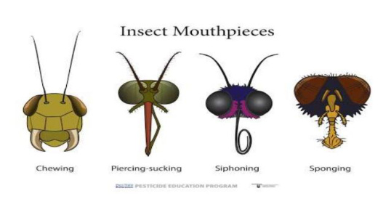

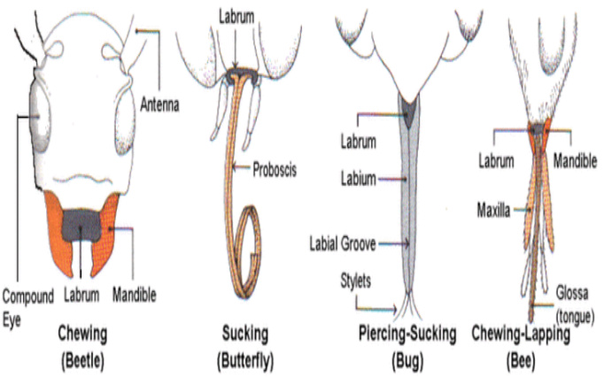

❖ Thorax:
➢ Divided into 3 regions.
1. Prothorax: Bears 1 pair of legs
2. Mesothorax: Bears 1 pair of legs, 1 pair of wings
3. Metathorax: Bears 1 pair of legs, 1 pair of wings
❖ Wings: Number of wings varies by species. In general, have 2 pairs.
➢ Mesothoracic wing: Forewing
➢ Metathoracic wing: Hindwing
❖ Functions
➢ Locomotion.
➢ Protection.
➢ Camouflage
❖ Wing modifications:
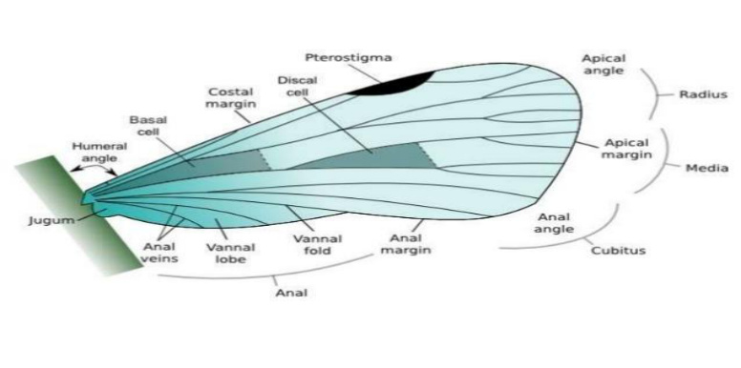

❖ TYPE OF WINGS:
Types
Remarks
Examples
Halters (Halter)
Knob-like reduced hind wings of
Diptera
House fly
Elytra (Elytron)
Hardened, protective forewings of
Coleoptera
Beetle and weevils
Hemelytra
Half-hardened, half-membranous
forewings of Hemiptera
Red cotton bug
Membranous wings
Dragon flies, bees, wasp,
grasshopper
Fringed wings
Modified wing structure of the
Thysanoptera
Thrips
Scales and hairs
Lepidoptera, Trichoptera,
some Diptera Moth and
butterflies
Tegmina
Cockroach

